**3. The stage III flying process**

With the same way as the stage II, we calculate the distance between every drone in the two patterns by using Euclidean distance and define and number the drones exactly the same as mentioned so as to utilize binary integer programming. However, in lieu of dividing the entire patterns into several groups or clustering, we regard the whole drone fleet as a whole, making the use of binary programming for a mere time to accomplish the goal. Possessing 477 drones in total, the formulas are as following likewise.

$$pdist=\sqrt{{(x_{1}-x_{2})}^{2}+{(y_{1}-y_{2})}^{2}+{(z_{1}-z_{2})}^{2}}$$

$$\min{Z}=\sum_{j=1}^{477}{\sum_{i=1}^{477}{d_{ij}c_{ij}}}$$

$$s.t.$$

$$\sum_{j=1}^{477}{c_{ij}≤1, i=1, 2, ⋯, 477}$$

$$\sum_{i=1}^{477}{c_{ij}=1, j=1,2,⋯,477}$$

We also apply LINGO to run the binary integer programming, the details of the code are in the attachment, part of the matching results is as the following in table ?:

Table ?: The matching result of the thir flying process

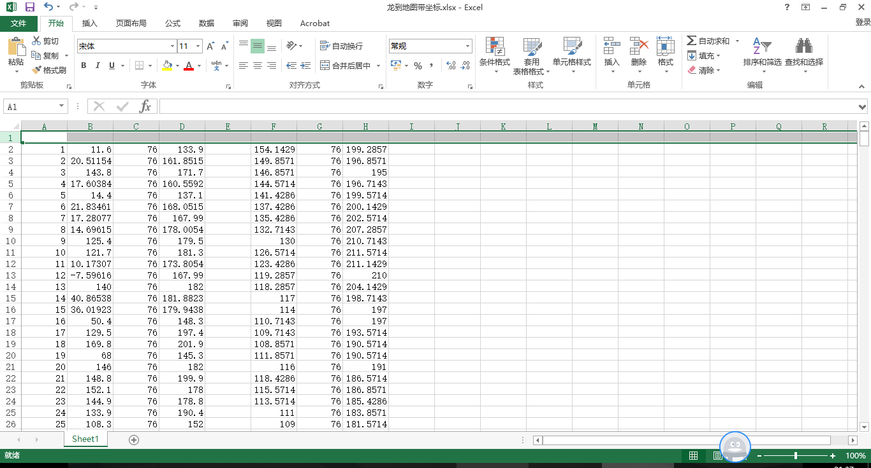

Column A, B, C respectively represents the x-coordinate, y-coordinate and z-coordinate of drones in the Ferris wheel. Column H represents the drone's original number. Column M, N, O respectively represents the x-coordinate, y-coordinate and z-coordinate of drones in the dragon. The complete results of the matching in the second process are in the attachment.